Chapter-07-Finding-the-path

**Hooks-UseState, React-Router, DynamicRouting, Error Handling 🔥**

1. **What is UseState?**

UseState must be used inside functional comp. It must not be called outside a func comp, inside for, if etc…

UseState is used to initialize variables.

The React useState Hook **allows us to track state in a function component**. State generally refers to data or properties that need to be tracking in an application.

useState accepts an initial state and returns two values:

* The current state.
* A function that updates the state.

import { useState } from "react";  
  
function FavoriteColor() {  
 const [color, setColor] = useState("");  
}

2. How to Track Images and how to use it?

Folder structure : src → assets → img -> foodvilla.png

To import:

import Logo from "../assets/img/foodvilla.png";  
src={Logo}

(or)

Using CDN

**3. Why CDN is best place to store images?**

Swiggy uses CDN to store images

In CDN we can’t optimize images. So we put images that are optimized.

**4. Is importing npm packages a good practice?**

Don’t use packages for simple task. Write it on your own. Only for complicated functionality use npm packages.

**5.Build forms in React?**

Formik : Build forms in react without the tears.

[**Formik**  
*Formik comes with battle-tested solutions for input validation, formatting, masking, arrays, and error handling. This…*formik.org](https://formik.org/)

**6. What is React Router DOM?**

[**Home v6.6.2**  
*The migration guide will help you migrate incrementally and keep shipping along the way. Or, do it all in one yolo…*reactrouter.com](https://reactrouter.com/en/main)

**7. How to install and use a package in React JS?**

[**createBrowserRouter v6.6.2**  
*This is the recommended router for all React Router web projects. It uses the DOM History API to update the URL and…*reactrouter.com](https://reactrouter.com/en/main/routers/create-browser-router)

**eg) react-router-dom**

npm i react-router-dom

Check in package.json

**App.js:**

import {createBrowserRouter, RouterProvider} from "react-router-dom" // comes from library  
  
const AppLayout = () => {  
return(  
<>  
<Header/>  
<Body/>  
<Footer/>   
</>  
)  
}  
  
const appRouter = createBrowserRouter([ //creating a router (array); it must come under Functional comp  
{  
path:"/",  
element:<AppLayout/>,  
},  
{  
path:"/about",  
element:<About/>,  
}  
])  
  
const root = ReactDOM.createRoot(document.getElementById("root");  
  
root.render(<RouterProvider router={appRouter} />); //provide router to render acco  
rding to the page

**8. How to create a Error Page?**

Create a Error Component

Add in App.js in appRouter → errorElement: <Error/>

import {createBrowserRouter, RouterProvider} from "react-router-dom"; // comes from library  
import Error from "../components/error";  
const AppLayout = () => {  
return(  
<>  
 <Header/>  
 <Body/>  
 <Footer/>   
</>  
)  
}  
  
const appRouter = createBrowserRouter([ //creating a router (array); it must come under Functional comp  
{  
 path:"/",  
 element:<AppLayout/>,  
 errorElement: <Error/>  
},  
{  
 path:"/about",  
 element:<About/>,  
}  
])  
  
const root = ReactDOM.createRoot(document.getElementById("root");  
  
root.render(<RouterProvider router={appRouter} />); //provide router to render according to the page

**9. What is useRouteError?**

It is an hook. It gives error Response.

Catch and Display Errors.

import { useRouteError } from 'react-router-dom';  
  
const Error = () => {  
const err = useRouteError();  
console.log(err)  
return(  
 <>  
 <p>{err.status + err.statusText}</p>  
 </>  
)  
}

**10. What is a SPA?**

Single Page Application does not reload while routing to different pages.

**11. Types of Routing**

Client side routing → Load different component without network calls. Client side routing **allows your app to update the URL from a link click without making another request for another document from the server**. Instead, your app can immediately render some new UI and make data requests with fetch to update the page with new information.

Server side routing → With server-side routing, **a user clicks a link that requests a new page or new data from the server (another computer).** **And then new data or document is served to the user**.

**12. What is Link?**

To call a route instead of using anchor tag use Link

Remix developers developed react-router-dom npm package.

The Link component uses anchor tag behind the scenes.

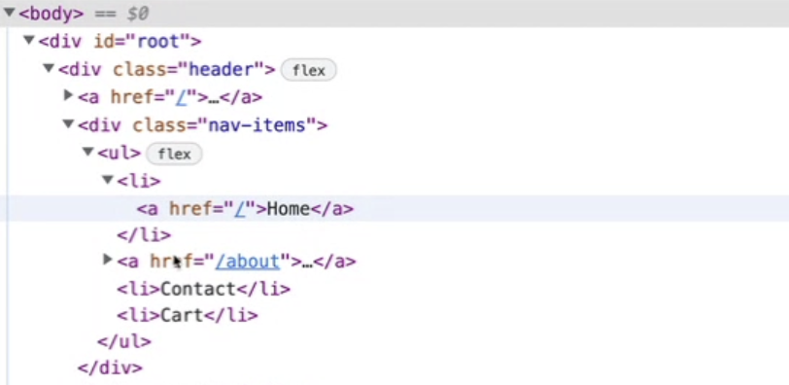Check in console. The <Link> Link tag is converted to <a> anchor tag

import {Link} from "react-router-dom";  
  
<Link to="/about">  
<li>About</li>  
</Link>

**13. Children of Route?**

**Outlet** will be filled by children components eg) body, contact, about.

Outlet is a Component. Remix developers developed react-router-dom npm package.

Reconciliation’s diff algorithm changes only the outlet. The header and footer remains the same.

import {createBrowserRouter, RouterProvider, Outlet} from "react-router-dom"; // comes from library  
import Error from "../components/error";  
  
const AppLayout = () => {  
return(  
<>  
 <Header/>  
// outlet to different pages  
<Outlet/>  
// <About/> // if path is /about  
// <Body/> // if path is /  
// <Contact/> // if path is /contact  
 <Footer/>   
</>  
)  
}  
  
const appRouter = createBrowserRouter([ //creating a router (array); it must come under Functional comp  
{  
 path:"/",  
 element:<AppLayout/>,  
 errorElement: <Error/>  
 children: [  
 {  
 path:"/",  
 element:<Body/>,  
 },  
 {  
 path:"/about",  
 element:<About/>,  
 },  
 {  
 path:"/contact",  
 element:<Contact/>,  
 }  
 ],  
},  
])  
  
const root = ReactDOM.createRoot(document.getElementById("root");  
  
root.render(<RouterProvider router={appRouter} />); //provide router to render according to the page

**14. What is Dynamic Route? What is useParams?**

id in url will come as a param.

useParams can read a dynamic URL.

import {useParams} from "react-router-dom"  
import {useEffect, useState} from "react"  
  
const Res = () => {  
const params = useParams(); // useParams can read a dynamic URL.  
const {id} = params;  
console.log(params)  
  
const [restaurant, setRestaurant] = useState({})  
  
  
useEffect(() => {  
getRestaurantInfo();  
}, [])  
  
async function getRestaurantInfo() {  
const data = await fetch("https://www.swiggy.com/dapi/menu/v4/full?lat=12.93519298ng=77.62448069999999&menuId=229")  
const json = await data.json();  
console.log(json)  
setRestaurant(json.data)  
}  
  
return (  
 <div>  
 <h1> Restraunt id:123 </h1>  
 <h2>Namaste</h2>  
 </div>  
 )  
}

import {createBrowserRouter, RouterProvider, Outlet} from "react-router-dom"; // comes from library  
import Error from "../components/error";  
  
const AppLayout = () => {  
return(  
<>  
 <Header/>  
 <Outlet/>  
 <Footer/>   
</>  
)  
}  
  
const appRouter = createBrowserRouter([ //creating a router (array); it must come under Functional comp  
{  
 path:"/",  
 element:<AppLayout/>,  
 errorElement: <Error/>  
 children: [  
 {  
 path:"/",  
 element:<Body/>,  
 },  
 {  
 path:"/about",  
 element:<About/>,  
 },  
 {  
 path:"/contact",  
 element:<Contact/>,  
 },  
 {  
 path:"/restraunt/:id",  
 element:<RestrauntMenu/>,  
 }  
 ],  
},  
])  
  
const root = ReactDOM.createRoot(document.getElementById("root");  
  
root.render(<RouterProvider router={appRouter} />); //provide router to render according to the page

**15. What is Object.values?**

The Object.values() static method returns an array of a given object's own enumerable string-keyed property values.

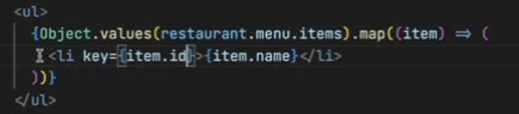

const object1 = {  
 a: 'somestring',  
 b: 42,  
 c: false  
};  
  
console.log(Object.values(object1));  
// Expected output: Array ["somestring", 42, false]  
Array ["somestring", 42, false]